Series

ORF-R

120V Preassembled Constant Wattage Heating Cable

for Roof and Gutter De-icing

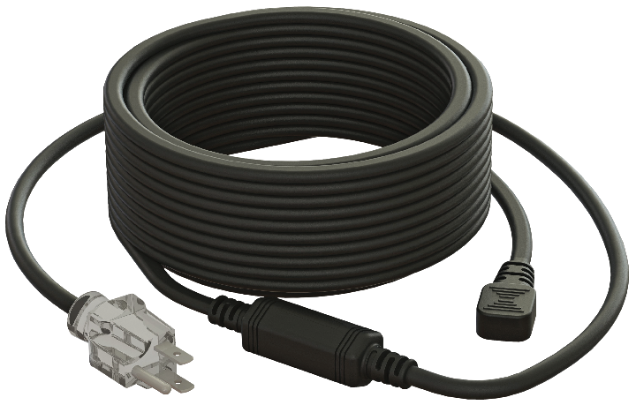



Features

Nominal voltage - 120V.

Linear density - 5 Watts per foot.

Cold lead length - 30 in. (0.76 m).

Outer jacket - PVC.

Bus wire - Nickel plated copper.

Bending radius, minimum - 1/2 in. (12 mm).

Included hardware - Roof clips for cable and spacers.

* Grounded 3-pronged plug with indicator light to show when the cable is on.

Installation - **Never cut or shorten the heating cable.**

* For outdoor applications only.
* Minimum installation temperature: 0 °C (34 °F).

Warranty - 1-year basic warranty on the heating cable.

Application - Roof and gutter de-icing.

**Models**

|  |  |  |  |  |
| --- | --- | --- | --- | --- |
| **Product #1** | **Length** | | **Watts** | **Qty** |
| **ft.** | **m** |
| **ORF-R020** | 20 | 6.1 | 100 |  |
| **ORF-R030** | 30 | 9.1 | 150 |  |
| **ORF-R060** | 60 | 18.3 | 300 |  |
| **ORF-R080** | 80 | 24.4 | 400 |  |
| **ORF-R100** | 100 | 30.5 | 500 |  |
| **ORF-R120** | 120 | 36.6 | 600 |  |
| **ORF-R140** | 140 | 42.7 | 700 |  |
| **ORF-R160** | 160 | 48.8 | 800 |  |
| **ORF-R180** | 180 | 54.9 | 900 |  |
| **ORF-R200** | 200 | 61.0 | 1000 |  |
| **ORF-R240** | 240 | 73.2 | 1200 |  |

*1 Must be plugged into a 120V outlet fitted with ground fault protection device (GFCI).*

**Options**

|  |  |  |
| --- | --- | --- |
| **Product #**  **Kit** | **Description** | **Qty** |
| **KIT-RF-CLIP** | Roof clips (25) and spacers (15) for constant wattage heating cables |  |
| **RCR-U** | Roof and gutter sentry for automatic de-icing control with humidity probe |  |

**Specifications may change without prior notice**

|  |  |
| --- | --- |
| Project: | Approval  Information |
| Consultant Engineer: |
| Electrician Contractor: |
| Distributor: |
| Date: |
| Contact in Ouellet: |
| Comments: | |