Series
ORF-R
120V Preassembled Constant Wattage Heating Cable
for Roof and Gutter De-icing

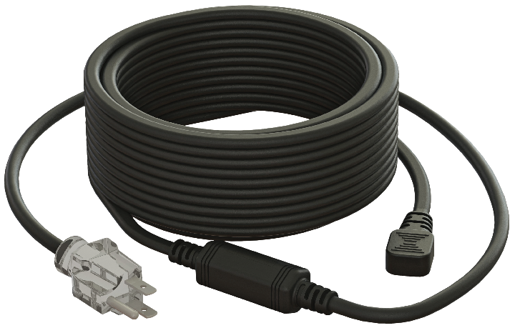

Features
Nominal voltage - 120V.
Linear density - 5 Watts per foot.
Cold lead length - 30 in. (0.76 m).
Outer jacket - PVC.
Bus wire - Nickel plated copper.
Bending radius, minimum - 1/2 in. (12 mm).
Included hardware - Roof clips for cable and spacers.
- Grounded 3-pronged plug with indicator light to show when the cable is on.
Installation - Never cut or shorten the heating cable.
- For residential outdoor applications only.
- Minimum installation temperature: 0 °C (32 °F).
Warranty - 1-year basic warranty on the heating cable.
Application - Roof and gutter de-icing.

Models
Product #¹ | Length |  | Watts | Qty
Product #¹ | ft. | m | Watts | Qty
ORF-R020 | 20 | 6.1 | 100
ORF-R030 | 30 | 9.1 | 150
ORF-R060 | 60 | 18.3 | 300
ORF-R080 | 80 | 24.4 | 400
ORF-R100 | 100 | 30.5 | 500
ORF-R120 | 120 | 36.6 | 600
ORF-R140 | 140 | 42.7 | 700
ORF-R160 | 160 | 48.8 | 800
ORF-R180 | 180 | 54.9 | 900
ORF-R200 | 200 | 61.0 | 1000
ORF-R240 | 240 | 73.2 | 1200

¹ Must be plugged into a 120V outlet fitted with ground fault protection device (GFCI).

Options
Product #  Kit | Description | Qty
KIT-RF-CLIP | Roof clips (25) and spacers (15) for constant wattage heating cables
RCR-U | Roof and gutter sentry for automatic de-icing control with humidity probe

Specifications may change without prior notice
Project: | Approval  Information
Consultant Engineer: | Approval  Information
Electrician Contractor: | Approval  Information
Distributor: | Approval  Information
Date: | Approval  Information
Contact in Ouellet: | Approval  Information
Comments:

