Series
OSKHE130R
ERV - Energy Recovery Ventilator with Recirculation

Top Port Model
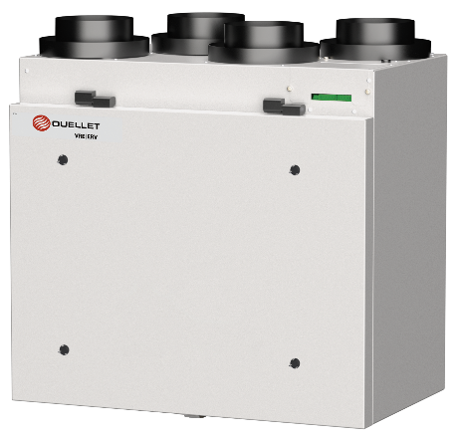
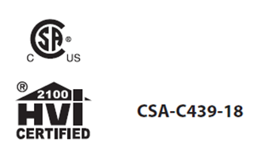

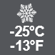

Features
Air flow and performance - Air ﬂow 130 cfm at 0.2 in.w.g.
- 75% sensible recovery effectiveness at 0 °C (32 °F) 30 L/s,
60% sensible recovery effectiveness at -25 °C (-13 °F) 27 L/s.
- Recirculation defrosts.
Voltage - 120V, 60Hz, 1.5A, 172W.
Benefit - Reduce heating demand in winter and cooling demand in summer.
- Whisper-quiet: factory calibrated and balanced.
- Easy installation and maintenance.
- Designed and manufactured in Canada to operate in variable climatic conditions.
Construction - Door and housing in corrosion-resistant galvanized steel,
24-gauge, pre-painted neutral white.
- Convenient, screwless hinged door.
- Ultra-thin: 14 1/8 in. (359 mm).
- Easy installation: 64 lb (29.1 kg).
- No drain required.
- Port size: 5 in. (127 mm).
- Top port model only.
- Merv8 washable filters. Merv13 washable filter in option (SK-FI-M13).
Motor - Energy-efficient, sealed European motor with closed housing and automatic reset
thermal protection.
- Balancing without flow keys. 100% electronic adjustment. Pressure ports integrated
into the door for precise, easy balancing.
Energy recovery core - Polymer counterflow energy recovery core offers high energy efficiency for superior performance.
- Washable in soapy water to recover its full effectiveness without deterioration
or contamination.

Control/timer - 2 control choices available:
- Optional Decora-style wall-mounted control/timer (SA-LT15).
INTERMITENT (20-40) – CONTINUOUS – OFF – Timer (20-40-60 minutes).
- Optional digital Decora-style wall-mounted control/timer (SA-LCD15).
INTERMITENT (20-40) – CONTINUOUS – Humidity – Recirculation – OFF.
Installation - Can be wall-mounted or suspended.
- Set of nylon suspension straps included for installation.
- Fits into a 24 in. (610 mm) deep wardrobe.
- Removable terminal block for connection to a furnace, supplied with the device.
Setting - Balance the unit using the supplied instruction.
- All the installer needs are the required flow rates, a manometer,
and 5 minutes to adjust and balance the system.
- Simply specify the air flow rates for LOW SPEED and HIGH SPEED.
- The static pressure of the system should ideally be less than or equal to the static
pressure indicated by the graph for HIGH SPEED.
- You don't have to worry about static pressure to limit air flow or adding flow keys as
other devices. All you must do is provide ducting that doesn't limit maximum flow,
and the unit's adjustments will allow you to fine-tune flow rates.
Warranty - Motor 5-year. Other parts except filters and pre-filters 1-year.
Application - The ideal solution for high-rise apartments and small to medium-size homes.
- The most efficient energy recovery ventilator on the market. Ideal for projects
requiring very high energy performance to benefit from all available credits and
subsidies.
- Purifies the air by expelling many pollutants, dust, and allergens to the outside,
while ensuring an equivalent supply of fresh air in the home.

Important note: No controls are included with the purchase of an ERV or HRV. SA-LT15 and SA-LCD15 controls must be purchased separately.

OSKHE130R
Top Port Model
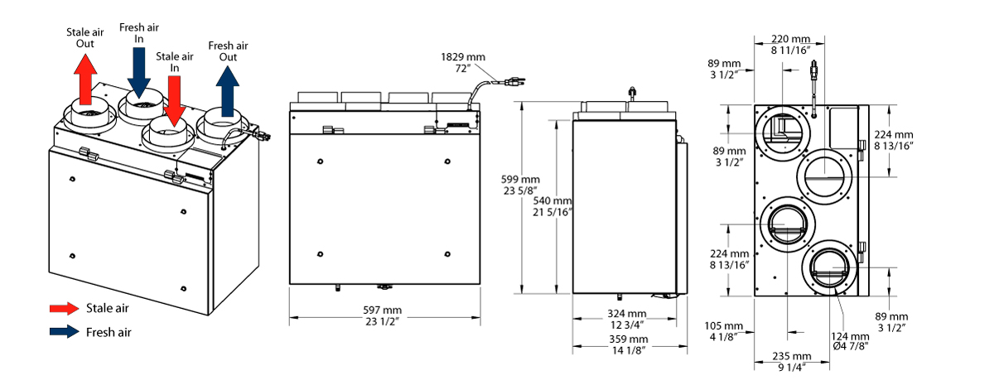
ERV OSKHE130R - Curves at highest speed
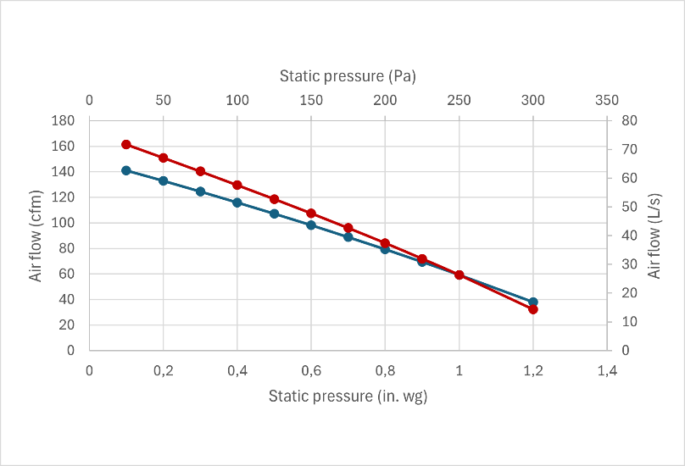
Fresh air
Stale air
Ventilation performance at highest speed
in. wg (Pa) | 0.2 (50) | 0.3 (75) | 0.4 (100) | 0.5 (125)
 | cfm (L/s) | cfm (L/s) | cfm (L/s) | cfm (L/s)
Net supply air flow | 129 (61) | 121 (57) | 113 (53) | 104 (49)
Gross  supply air flow | 133 (62) | 124 (58) | 116 (54) | 107 (50)
Gross  exhaust air flow | 151 (71) | 140 (66) | 129 (61) | 118 (56)

Energy ratings - HVI certified
Supply temperature |  | Air flow |  | Power | Sensible recovery (SRE)¹ | Adjusted sensible recovery | Latent recovery /  moisture transfer
°C | °F | cfm | L/s | W | % | % | %
Heating
0 | 32 | 49 | 23 | 66 | 78 | 87 | 86
0 | 32 | 64 | 30 | 76 | 75 | 84 | 81
0 | 32 | 84 | 40 | 92 | 73 | 80 | 77
-25 | -13 | 58 | 27 | 82 | 60 | 64 | 72
Cooling |  |  |  |  | Total recovery efficiency | Adjusted total recovery efficiency
35 | 95 | 64 | 30 | 76 | 68 | 74 | 77

Model
Product # | cfm | Recirculation | SRE¹  0 °C (32 °F) 30 L/s | SRE¹  -25 °C (-13 °F) 27 L/s | Port |  | Volts | Hertz | Amp. | Weight
 |  |  |  |  | in. | mm | Volts | Hertz | Amp. | lb | kg
ERV energy recovery ventilator 130 cfm with recirculation Top Port
OSKHE130RT | 130 | Yes | 75% | 60% | 5 | 127 | 120 | 60 | 1.5 | 64 | 29.1
¹ SRE: Sensitive Recovery Effectiveness.

Options
Product #  Kit | Product #  Factory installed* | Description | Qty
KIT-OSA-INS-5 | - | Basic installation kit for ERV and HRV, 5 in. (127 mm) ducts
KIT-SA-FI-150 | - | Kit of 2 Merv8 washable filters for ERV 130R and HRV 150R
KIT-SK-DRAIN | - | Drain connection kit for ERV and HRV
SK-FI-M13 | - | Merv13 washable filter for ERV 130R and HRV 150R
* For factory installed options, add the option number to the product number. See the Product Code section inside the front cover.

Controls sold separately
Product # | Description | Qty
SA-LT15² | Decora-style wall-mounted control/timer for residential ERV and HRV
SA-LCD15² | Digital Decora-style wall-mounted control/timer for residential ERV and HRV
² Must be purchased separately

Others
Type | Quantity | Model and description  Complementary informations | Volts | Phase | Watts | Length  mm/in. | Informations  Color/installation

Specifications may change without prior notice
Project: | Approval  Information
Consultant Engineer: | Approval  Information
Electrical Contractor: | Approval  Information
Distributor: | Approval  Information
Date: | Approval  Information
Contact at manufacturer: | Approval  Information
Comments:

