Series
OSR-HA High Temperature Self-Regulating Heating Cable ELSR-HA

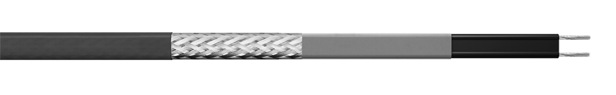




Features
Outer jacket - Fluoropolymer (BOT).
Bus wire - Nickel plated copper, 16 AWG.
Minimum start-up
temperature - -30 °C (-22 °F).
Maximum operating
Temperature (power on) - 120 °C (248 °F).
Maximum continuous
exposure temperature
(power off) - 150 °C (302 °F), continuous.
- 200 °C (392 °F), power off for 1000 hr cumulative.
Nominal voltage - 120V, 240/208V, 277V.
Bending radius, min. - 25 mm (1 in.).
Installation temperature, min. - -45 °C (-49 °F).
Classification - T 200 °C Db.
- Class I Div 1, Groups A, B, C, D (Contact manufacturer).
- Class I, Division 2, Groups A, B, C, D.
- Class II Div 1 Groups E, F, G (Contact manufacturer).
- Class II, Division 2, Groups E, F, G.
- Class III Div 1, T2D/T3.
- Zone1, AEx 60079-30-1 IIC T2D/T3 Gb.
- Zone1, Ex 60079-30-1 IIC T2D/T3 Gb.
Standards - CSA C22.2.130; -WS.
- CAN/CSA 60079-7:12, 60079-0-11
- ANSI/IEEE 515, 515.
- IEC/IEEE 60079-30-1.
- IEEE 515/CSA 22.2 130-16.
- UL 60079-30-1.
Certification - IECEx EPS 12.0006U.
- 12ATEX1429U.
- CSA C US 2547790.
- FM22US0062X.
- FM22CA0044X.
Rating - Wet rated, for outdoor use (WS).
Warranty - 1-year basic warranty on the heating cable.
Application - Freeze protection, heat tracing instrumentation, pipes, vessel and tanks, chemical
and petrochemical industries, food processing, automotive.

Heating Circuit Length for ELSR-HA Models
120V |  |  |  |  |  |  |  |  | 240V
Start-up temperature | CB capacity (A) | Maximum heating circuit (ft.) for |  |  |  |  |  | Start-up temperature | CB capacity (A) | Maximum heating circuit (ft.) for
Start-up temperature | CB capacity (A) | ELSR-HA-3-1 | ELSR-HA-7-1 | ELSR-HA-10-1 | ELSR-HA-15-1 | ELSR-HA-20-1 |  | Start-up temperature | CB capacity (A) | ELSR-HA-3-2 | ELSR-HA-7-2 | ELSR-HA-10-2 | ELSR-HA-15-2 | ELSR-HA-20-2
10 °C  (50 °F) | 10 | 209 | 112 | 92 | 58 | 42 |  | 10 °C  (50 °F) | 10 | 519 | 243 | 170 | 104 | 78
10 °C  (50 °F) | 15 | 307 | 167 | 138 | 86 | 63 |  | 10 °C  (50 °F) | 15 | 697 | 365 | 255 | 156 | 117
10 °C  (50 °F) | 20 | 307 | 223 | 185 | 116 | 85 |  | 10 °C  (50 °F) | 20 | 697 | 473 | 340 | 207 | 155
10 °C  (50 °F) | 25 | 307 | 225 | 204 | 145 | 106 |  | 10 °C  (50 °F) | 25 | 697 | 473 | 391 | 259 | 194
10 °C  (50 °F) | 30 | 307 | 225 | 204 | 160 | 127 |  | 10 °C  (50 °F) | 30 | 697 | 473 | 391 | 301 | 233
10 °C  (50 °F) | 35 | 307 | 225 | 204 | 160 | 135 |  | 10 °C  (50 °F) | 35 | 697 | 473 | 391 | 301 | 259
10 °C  (50 °F) | 40 | 307 | 225 | 204 | 160 | 135 |  | 10 °C  (50 °F) | 40 | 697 | 473 | 391 | 301 | 259
0 °C  (32 °F) | 10 | 200 | 107 | 89 | 56 | 40 |  | 0 °C  (32 °F) | 10 | 488 | 229 | 161 | 99 | 74
0 °C  (32 °F) | 15 | 300 | 161 | 133 | 83 | 60 |  | 0 °C  (32 °F) | 15 | 697 | 343 | 242 | 149 | 110
0 °C  (32 °F) | 20 | 307 | 215 | 178 | 111 | 80 |  | 0 °C  (32 °F) | 20 | 697 | 457 | 322 | 198 | 147
0 °C  (32 °F) | 25 | 307 | 225 | 204 | 139 | 100 |  | 0 °C  (32 °F) | 25 | 697 | 473 | 391 | 247 | 184
0 °C  (32 °F) | 30 | 307 | 225 | 204 | 160 | 120 |  | 0 °C  (32 °F) | 30 | 697 | 473 | 391 | 297 | 221
0 °C  (32 °F) | 35 | 307 | 225 | 204 | 160 | 135 |  | 0 °C  (32 °F) | 35 | 697 | 473 | 391 | 301 | 258
0 °C  (32 °F) | 40 | 307 | 225 | 204 | 160 | 135 |  | 0 °C  (32 °F) | 40 | 697 | 473 | 391 | 301 | 259
-10 °C  (14 °F) | 10 | 192 | 103 | 86 | 54 | 38 |  | -10 °C  (14 °F) | 10 | 461 | 216 | 153 | 94 | 70
-10 °C  (14 °F) | 15 | 288 | 155 | 128 | 81 | 58 |  | -10 °C  (14 °F) | 15 | 691 | 323 | 229 | 142 | 105
-10 °C  (14 °F) | 20 | 307 | 207 | 170 | 107 | 76 |  | -10 °C  (14 °F) | 20 | 697 | 431 | 306 | 189 | 140
-10 °C  (14 °F) | 25 | 307 | 225 | 204 | 134 | 95 |  | -10 °C  (14 °F) | 25 | 697 | 473 | 382 | 237 | 175
-10 °C  (14 °F) | 30 | 307 | 225 | 204 | 160 | 114 |  | -10 °C  (14 °F) | 30 | 697 | 473 | 391 | 284 | 210
-10 °C  (14 °F) | 35 | 307 | 225 | 204 | 160 | 134 |  | -10 °C  (14 °F) | 35 | 697 | 473 | 391 | 301 | 245
-10 °C  (14 °F) | 40 | 307 | 225 | 204 | 160 | 135 |  | -10 °C  (14 °F) | 40 | 697 | 473 | 391 | 301 | 259
-30 °C  (-22 °F) | 10 | 178 | 97 | 79 | 50 | 34 |  | -30 °C  (-22 °F) | 10 | 414 | 194 | 138 | 87 | 64
-30 °C  (-22 °F) | 15 | 266 | 145 | 118 | 75 | 52 |  | -30 °C  (-22 °F) | 15 | 622 | 291 | 208 | 130 | 95
-30 °C  (-22 °F) | 20 | 307 | 194 | 158 | 100 | 70 |  | -30 °C  (-22 °F) | 20 | 697 | 388 | 278 | 174 | 127
-30 °C  (-22 °F) | 25 | 307 | 225 | 198 | 126 | 87 |  | -30 °C  (-22 °F) | 25 | 697 | 473 | 347 | 217 | 159
-30 °C  (-22 °F) | 30 | 307 | 225 | 204 | 150 | 104 |  | -30 °C  (-22 °F) | 30 | 697 | 473 | 391 | 261 | 191
-30 °C  (-22 °F) | 35 | 307 | 225 | 204 | 160 | 122 |  | -30 °C  (-22 °F) | 35 | 697 | 473 | 391 | 301 | 222
-30 °C  (-22 °F) | 40 | 307 | 225 | 204 | 160 | 135 |  | -30 °C  (-22 °F) | 40 | 697 | 473 | 391 | 301 | 254

277V
Start-up temperature | CB capacity (A) | Maximum heating circuit (ft.) for
Start-up temperature | CB capacity (A) | ELSR-HA-3-2 | ELSR-HA-7-2 | ELSR-HA-10-2 | ELSR-HA-15-2 | ELSR-HA-20-2
10 °C  (50 °F) | 10 | 571 | 298 | 185 | 120 | 102
10 °C  (50 °F) | 15 | 856 | 447 | 276 | 180 | 153
10 °C  (50 °F) | 20 | 1115 | 596 | 368 | 240 | 204
10 °C  (50 °F) | 25 | 1115 | 744 | 461 | 300 | 255
10 °C  (50 °F) | 30 | 1115 | 847 | 553 | 360 | 306
10 °C  (50 °F) | 35 | 1115 | 847 | 645 | 420 | 357
10 °C  (50 °F) | 40 | 1115 | 847 | 730 | 479 | 408
0 °C  (32 °F) | 10 | 537 | 280 | 174 | 114 | 97
0 °C  (32 °F) | 15 | 805 | 420 | 261 | 172 | 145
0 °C  (32 °F) | 20 | 1074 | 560 | 348 | 229 | 193
0 °C  (32 °F) | 25 | 1115 | 700 | 436 | 286 | 242
0 °C  (32 °F) | 30 | 1115 | 840 | 522 | 343 | 290
0 °C  (32 °F) | 35 | 1115 | 847 | 609 | 400 | 338
0 °C  (32 °F) | 40 | 1115 | 847 | 697 | 458 | 386
-10 °C  (14 °F) | 10 | 507 | 265 | 165 | 109 | 91
-10 °C  (14 °F) | 15 | 760 | 396 | 248 | 164 | 138
-10 °C  (14 °F) | 20 | 1014 | 528 | 330 | 219 | 184
-10 °C  (14 °F) | 25 | 1115 | 661 | 413 | 274 | 230
-10 °C  (14 °F) | 30 | 1115 | 793 | 496 | 329 | 275
-10 °C  (14 °F) | 35 | 1115 | 847 | 578 | 384 | 321
-10 °C  (14 °F) | 40 | 1115 | 847 | 661 | 438 | 368
-30 °C  (-22 °F) | 10 | 456 | 237 | 150 | 101 | 84
-30 °C  (-22 °F) | 15 | 684 | 357 | 224 | 151 | 125
-30 °C  (-22 °F) | 20 | 912 | 475 | 299 | 201 | 167
-30 °C  (-22 °F) | 25 | 1115 | 594 | 374 | 252 | 209
-30 °C  (-22 °F) | 30 | 1115 | 712 | 449 | 302 | 251
-30 °C  (-22 °F) | 35 | 1115 | 831 | 523 | 352 | 292
-30 °C  (-22 °F) | 40 | 1115 | 847 | 599 | 402 | 334
Maximum heating circuit ELSR-HA-XX on the following conditions:
• 120/240/277 Voltage • MCB type QO (100% utilization)
• Voltage drop max. 10% • Single cable fed 1 end
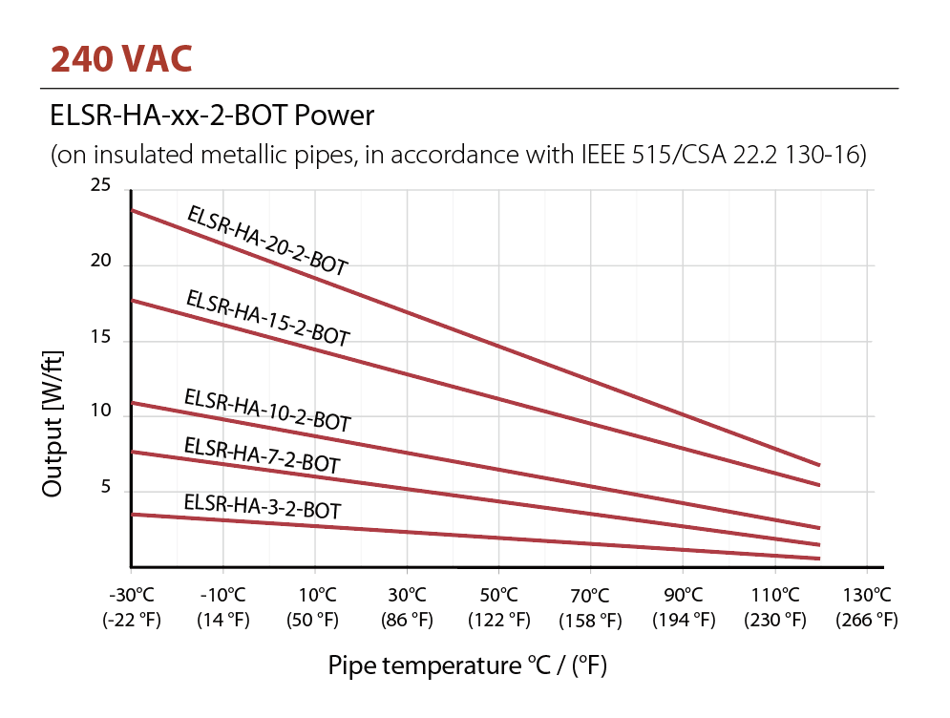
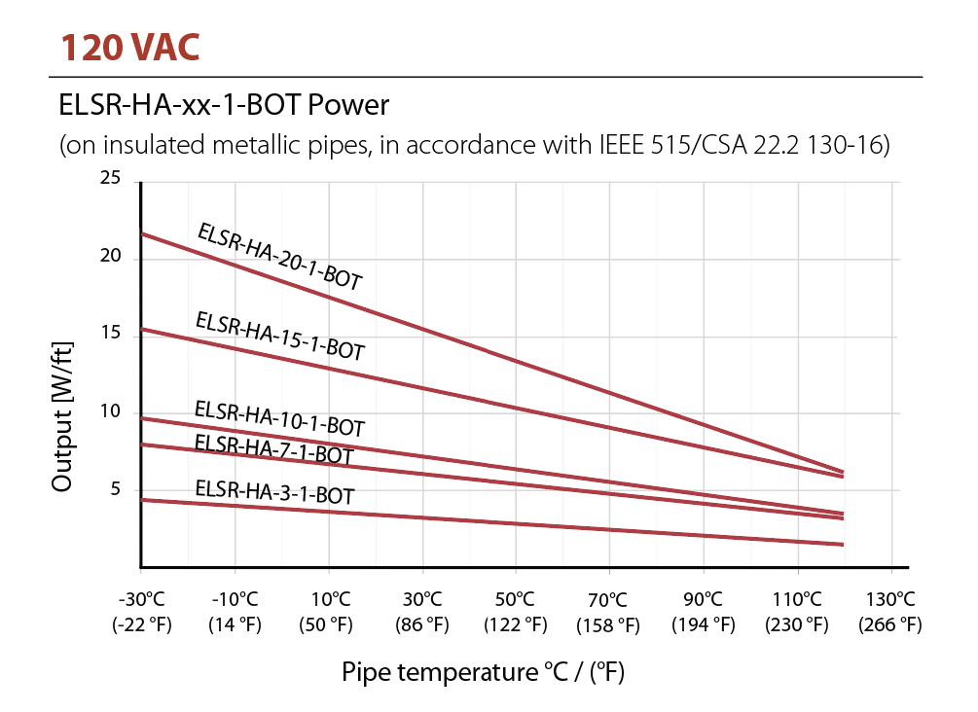

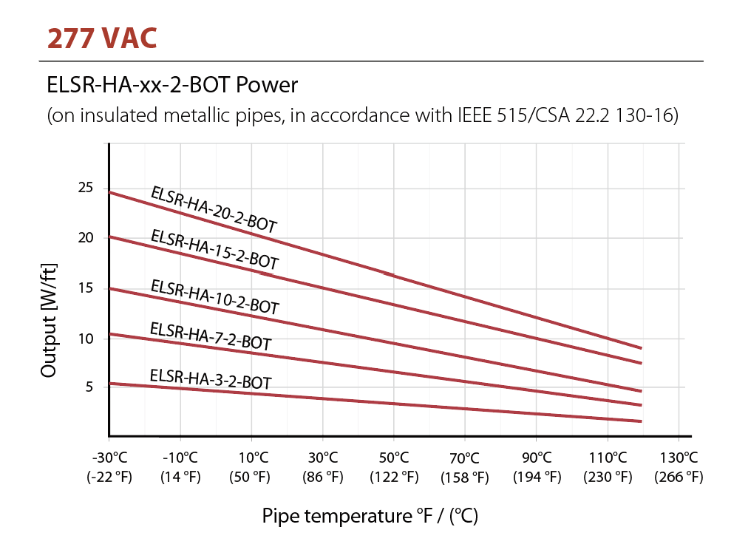
Eltherm® Correction Factors/Multipliers for Operation of Heating Cables in 208V
To calculate the corrected power output for operation in 208V, multiply the published output at 240V (in W/ft.) by the nominal output factor provided for the applicable heating cable type.
To calculate maximum heating circuit lengths for operation in 208V (tables provided in product data sheets), multiply the published max. heating circuit length at 240V provided for the applicable heating cable type.

Heating Cable  Correction Factors/ Multipliers | Nominal Output  208V vs. 240V | Heating Circuit Length  208V vs. 240V
ELSR-HA-XX-2 | 0.74 | 1.00

OSR Series ELSR-HA Models
Nominal  Output  W/ft. | Product # |  | Qty | Cable dimension approx.(mm)
Nominal  Output  W/ft. | 120V^{1, 3} | 240V/277V^{1, 2, 3} | Qty | Cable dimension approx.(mm)
3 | ELSR-HA-3-1-BOT | ELSR-HA-3-2-BOT |  | 12.4 x 5.9
7 | ELSR-HA-7-1-BOT | ELSR-HA-7-2-BOT |  | 12.4 x 5.9
10 | ELSR-HA-10-1-BOT | ELSR-HA-10-2-BOT |  | 12.4 x 5.9
15 | ELSR-HA-15-1-BOT | ELSR-HA-15-2-BOT |  | 12.4 x 5.9
20 | ELSR-HA-20-1-BOT | ELSR-HA-20-2-BOT |  | 12.4 x 5.9

¹ BOT Protective braid and a fluoropolymer outer jacket.
² For operations at 208V, please consult Correction Factors/Multipliers.
³ When ordering, the quantity on the purchase order is equal to the length in feet of the cable required.
E.g.: To order a 500 ft., cable, write 500 for quantity with product code.
Custom cutting service available for all lengths other than 500 ft. and 1000 ft. (minimum of 25 ft.).
Options
Product #  Kit | Description | Qty
ELVB-SRAH-34-ST | Power connection with steel/zinc cable gland/fitting, 3/4'' NPT, non-hazardous location
ELVB-SRAH | Power connection without cable gland
EL-ECH-EX¹ | End termination for ELSR-HA
KIT-OSR-ELSR-HA | End and power termination kit with warning sticker HA Series
ECA-JB1 | Junction box for single connection c/w label and fastener
ECA-JB2 | Junction box for double connection c/w label and fastener
ELAK-3-7 | Junction box with mounting stand for non-hazardous (ordinary) and hazardous locations
ELVB-SREX-34-HT¹ | Power connection with nickel plated cable gland, 3/4'' NPT, hazardous location
ELVB-SREX-M20-HT¹ | Power connection with nickel plated cable gland, M20, hazardous location
EX-IT-LAG | End of line termination device with green LED light and termination kit. NEMA 4X  for non-hazardous locations.
EX-IT-LAR | End of line termination device with red LED light and termination kit. NEMA 4X for non-hazardous locations.
Multiple applications
KIT-OSR-EL-WS03 | Warning label/sign bilingual (English / French)
Roof and gutter
ELB-20 | Downspout 90° mounting plate
ELB-21 | Gutter mounting plate
ELB-RCLIP-B | Roof clips black anodized, package of 25
Pipe tracing
ELB-02B | Self-adhesive glass fiber tape, max. temp. = 90 °C (194 °F), 50 m (165 ft.)
ELB-06C | Self-adhesive aluminum tape, max. temp. = 80 °C (176 °F), 50 m (165 ft.)

¹ Minimum installation temperature -45 °C (-49 °F).

Controls
Product # | Description | Qty
Controller options for roof and gutter for de-icing
DS-2C¹ | Aerial mounted controller with sensor to detect humidity and temperature, 30A, 100V to 277V
DS-8C¹ | Aerial mounted controller with sensor to detect temperature and a sensor to detect humidity with 10 ft. (3 m) cable,  30A, 100V to 277V
DS-9C¹ | Aerial mounted controller with sensor to detect temperature and a sensor to detect humidity with 10 ft. (3 m) cable,  2 X 30A, 100V to 277V
EX-50 | 50 ft. (15 m) extension kit, with connection fittings for humidity sensor
CDP-2 | Interior controller and display for DS products
ETO2¹ | Dual-zone electronic controller, 3 X 16A, 120V to 240V
ETF-744/99 | 24V outdoor sensor for measuring temperature
ETOR-55 | Gutter sensor to detect humidity with 33 ft. (10 m) cable
Controller options for pipe tracing for use in non-hazardous (ordinary) locations
ECA-E55-R25HT¹ | SPDT, NEMA 4X thermostat in molded aluminum housing, 22A at 120/250/480V, with 10 ft. (3 m) stainless steel bulb and capillary
TPR-L1N-3X-Q10¹ | SPDT, NEMA 4X thermostat in polycarbonate housing, 22A at 120/250/480V, with 3 ft. (1 m) tinned copper bulb  and capillary
TPR-L1N-10X-Q10¹ | SPDT, NEMA 4X thermostat in polycarbonate housing, 22A at 120/250/480V, with 10 ft. (3 m) tinned copper bulb  and capillary
TRF115-005¹ | SPDT, NEMA 4X thermostat, range -17 °C to 49 °C (0 °F to 120 °F), 25A at 120/208/240/277V, with 5 ft. (1.5 m) stainless bulb  and capillary
TRF115-007¹ | SPDT, NEMA 4X thermostat, range -35 °C to 38 °C (-30 °F to 100 °F), 25A at 120/208/240/277V, with 8 ft. (2.4 m) copper bulb  and capillary
ELTC-14-RTD¹ | Digital temperature control 20A at 90-260V, including 3-wire RTD (Pt-100) sensing element is 5x50mm with 5m of fluoropolymer lead wires, range 0 to 250°C
GPT-130 | Single point heat trace control thermostat NEMA 4X c/w GFEP and a 20 ft. thermistor 30A@100-277V
S1-A | NEMA 4X IP67 electronic single point line sensing heat trace controller 100-277V, 30A c/w built-in 30 mA GFEP  and 20' (6 m) lead, 10k ohms thermistor, Wi-Fi, Ethernet, Modbus and BACnet³ capabilities
S1-B | NEMA 4X IP67 electronic single point line sensing heat trace controller 100-277V, 30A c/w built-in 30 mA GFEP  and 20' (6 m) lead, 10k ohms thermistor, Wi-Fi, Ethernet
GATEWAY-PCKG | 24VDC BACnet gateway assembly with power supply NEMA 4X enclosure with 24VDC transformer for S1 Series
GATEWAY | 24VDC BACnet gateway stand alone for S1 Series
Controller options for pipe tracing for use in non-hazardous (ordinary) and hazardous locations
E121-13273¹ | Explosion -proof NEMA 4X 7, 9 and IP66 epoxy painted die cast aluminum line sensing thermostat  temperature control 120-480V, 22A, SPDT c/w 10 ft. (3 m) stainless steel capillary,
TM-1SIH1-E5-RTD-A1 | TraceMateTM I GFCI electronic thermostat for single circuit at 120V
TM-1DIH2-E5-RTD-A1 | TraceMateTM I GFCI electronic thermostat for single circuit at 240/208V
TM-2SIH1-E5-RTD | TraceMateTM II GFCI electronic thermostat for dual circuit at 120V
TM-2DIH2-E5-RTD | TraceMateTM II GFCI electronic thermostat for dual circuit at 240/208V
MS-2101² | MasterTrace Single circuit electronic GFCI controller with double pole, 85V to 280V, 30A, with user interface
MS-2102² | MasterTrace Double circuit electronic GFCI controller with single pole, 120V or 277V, 30A, with user interface
RTD-7 | RTD probe for MasterTrace controller
Control panel options
SR-4CIR-240 | 4 circuits 240V 30A circuit GFEP control panel with contactors and 240-120V control transformer (HxWxD: 20x16x8 in.)
SR-6CIR-240 | 6 circuits 240V 30A circuit GFEP control panel with contactors and 240-120V control transformer (HxWxD: 20x16x8 in.)
SR-8CIR-240 | 8 circuits 240V 30A circuit GFEP control panel with contactors and 240-120V control transformer (HxWxD: 24x20x8 in.)
SR-12CIR-240 | 12 circuits 240V 30A circuit GFEP control panel with contactors and 240-120V control transformer (HxWxD: 24x24x8 in.)

¹ Requires a ground fault circuit interrupter (GFCI) in the electrical panel.
² Requires a RTD probe for MasterTrace controller (RTD-7).
³ BACnet IP or MS/TP available via preconfigured SMC gateway, sold separately.

Specifications may change without prior notice
Project: | Approval  Information
Consultant Engineer: | Approval  Information
Electricial Contractor: | Approval  Information
Distributor: | Approval  Information
Date: | Approval  Information
Contact in Ouellet: | Approval  Information
Comments:

