Series
ODB Aluminum Draft Barrier
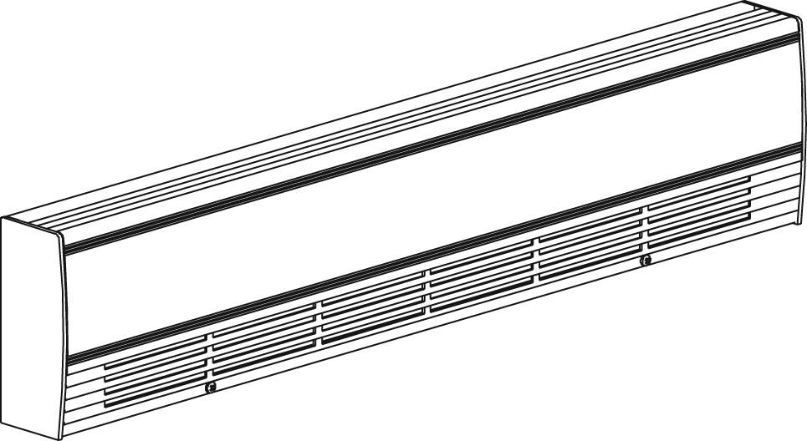
With bottom
fresh air inlet

Features
Color - Standard: white, almond.
- Optional (upcharge applicable): metallic silver, bronze, metallic charcoal,
aluminum, semi-gloss black, sand.
- Custom colors available upon request.
Finish - Standard: epoxy/polyester powder paint.
- Optional: anodized aluminum.
Voltage - 120V, 208V, 240/208V, 277V, 347V, 600V, 50/60 Hz, 1-phase.
Construction - 14-gauge (0.0787 in. [2 mm]) aluminum front cover.
- 18-gauge satin coat steel cabinet.
- Screw assembly for added strength.
- Full length built-in wireway.
- Pencil-proof openings less than 1/4 in. (6.4 mm).
- Front fresh air inlet; top warm air outlet.
- Bottom fresh air inlet available (-BAI).
- Clean back available (-BD).
- Linear high-limit temperature control with automatic reset.
High altitude version available (-HA).
- End caps included.
Heating element - Stainless steel tubular heating element with aluminum ﬁns.
- Floating heating element on high-temperature nylon bushings
reducing expansion noises.
Watt density - Average standard watt density of 275W/ft.
- Average low watt density of 100W/ft., 150W/ft., 200W/ft.
Control - Built-in thermostat available with a control knob
or tamperproof.
- Mechanical, electronic or pneumatic relays available
(installed on the right end only).
Ouellet highly recommends to use an electronic wall thermostat for greater comfort.
Installation - Heater must be installed at least 2 in. (51 mm) from finished floor (for -BAI option).
- Mounting holes spaced on 4 in. (102 mm) intervals for ease of installation.
- Wall or floor mounted installation.
- Variety of accessories available for wall-to-wall installation.
- Pedestal kit available.
Warranty - 10-year warranty against defects.
Application - Commercial building, office building, hospital, daycare center, private residence.

Standard Watt Density Models
Watts | Watts  240/208V | Product # |  |  |  |  |  |  |  | Length |  | Weight
Watts | Watts  240/208V | 120V | Qty | 208V | Qty | 240/208V | Qty | 277V | Qty | in. | mm | lb | kg
500 | 500/375 | ODB0502 |  | ODB0508 |  | ODB0500 |  | ODB0577 |  | 29 _{1/16} | 738 | 8.0 | 3.6
750 | 750/563 | ODB0752 |  | ODB0758 |  | ODB0750 |  | ODB0777 |  | 39 _{1/16} | 992 | 10.4 | 4.7
1000 | 1000/750 | ODB1002 |  | ODB1008 |  | ODB1000 |  | ODB1077 |  | 49 _{5/16} | 1253 | 12.8 | 5.8
1250 | 1250/938 | ODB1252 |  | ODB1258 |  | ODB1250 |  | ODB1277 |  | 58 _{13/16} | 1494 | 15.1 | 6.8
1500 | 1500/1125 | ODB1502 |  | ODB1508 |  | ODB1500 |  | ODB1577 |  | 67 _{1/2} | 1715 | 17.2 | 7.8
1750 | 1750/1313 | - | - | ODB1758 |  | ODB1750 |  | ODB1777 |  | 76 _{7/8} | 1952 | 19.4 | 8.8
2000 | 2000/1500 | - | - | ODB2008 |  | ODB2000 |  | ODB2077 |  | 85 _{5/8} | 2175 | 21.5 | 9.7
2250 | 2250/1688 | - | - | ODB2258 |  | ODB2250 |  | ODB2277 |  | 94 _{1/2} | 2400 | 23.6 | 10.7
2500 | 2500/1875 | - | - | ODB2508 |  | ODB2500 |  | ODB2577 |  | 103 _{5/8} | 2632 | 25.8 | 11.7

Low Watt Density Models
Product #¹ | Length | Weight | Average  Density W/ft. | Watts | Watts  240/208V¹ | 120V | Qty | 208V | Qty | 240/208V | Qty | 277V | Qty
ODB020X-738 | 29 1/16"  (738 mm) | 8.0 lb  (3.6 kg) | 100 | 200 | 200/150 | √ |  | √ |  | √ |  | ----- | -----
ODB030X-738 | 29 1/16"  (738 mm) | 8.0 lb  (3.6 kg) | 150 | 300 | 300/225 | √ |  | √ |  | √ |  | ----- | -----
ODB040X-738 | 29 1/16"  (738 mm) | 8.0 lb  (3.6 kg) | 200 | 400 | 400/300 | √ |  | √ |  | √ |  | √
ODB030X-992 | 39 1/16"  (992 mm) | 10.4 lb  (4.7 kg) | 100 | 300 | 300/225 | √ |  | √ |  | √ |  | √
ODB045X-992 | 39 1/16"  (992 mm) | 10.4 lb  (4.7 kg) | 150 | 450 | 450/338 | √ |  | √ |  | √ |  | √
ODB060X-992 | 39 1/16"  (992 mm) | 10.4 lb  (4.7 kg) | 200 | 600 | 600/450 | √ |  | √ |  | √ |  | √
ODB040X-1253 | 49 5/16"  (1253 mm) | 12.8 lb  (5.8 kg) | 100 | 400 | 400/300 | √ |  | √ |  | √ |  | √
ODB060X-1253 | 49 5/16"  (1253 mm) | 12.8 lb  (5.8 kg) | 150 | 600 | 600/450 | √ |  | √ |  | √ |  | √
ODB080X-1253 | 49 5/16"  (1253 mm) | 12.8 lb  (5.8 kg) | 200 | 800 | 800/600 | √ |  | √ |  | √ |  | √
ODB050X-1494 | 58 13/16"  (1494 mm) | 15.1 lb  (6.8 kg) | 100 | 500 | 500/375 | √ |  | √ |  | √ |  | √
ODB075X-1494 | 58 13/16"  (1494 mm) | 15.1 lb  (6.8 kg) | 150 | 750 | 750/563 | √ |  | √ |  | √ |  | √
ODB100X-1494 | 58 13/16"  (1494 mm) | 15.1 lb  (6.8 kg) | 200 | 1000 | 1000/750 | √ |  | √ |  | √ |  | √
ODB060X-1715 | 67 1/2"  (1715 mm) | 17.2 lb  (7.8 kg) | 100 | 600 | 600/450 | √ |  | √ |  | √ |  | √
ODB090X-1715 | 67 1/2"  (1715 mm) | 17.2 lb  (7.8 kg) | 150 | 900 | 900/675 | √ |  | √ |  | √ |  | √
ODB120X-1715 | 67 1/2"  (1715 mm) | 17.2 lb  (7.8 kg) | 200 | 1200 | 1200/900 | √ |  | √ |  | √ |  | √
ODB070X-1952 | 76 7/8"  (1952 mm) | 19.6 lb  (8.8 kg) | 100 | 700 | 700/525 | √ |  | √ |  | √ |  | √
ODB105X-1952 | 76 7/8"  (1952 mm) | 19.6 lb  (8.8 kg) | 150 | 1050 | 1050/788 | √ |  | √ |  | √ |  | √
ODB140X-1952 | 76 7/8"  (1952 mm) | 19.6 lb  (8.8 kg) | 200 | 1400 | 1400/1050 | √ |  | √ |  | √ |  | √
ODB080X-2175 | 85 5/8"  (2175 mm) | 21.5 lb  (9.7 kg) | 100 | 800 | 800/600 | √ |  | √ |  | √ |  | √
ODB120X-2175 | 85 5/8"  (2175 mm) | 21.5 lb  (9.7 kg) | 150 | 1200 | 1200/900 | √ |  | √ |  | √ |  | √
ODB160X-2175 | 85 5/8"  (2175 mm) | 21.5 lb  (9.7 kg) | 200 | 1600 | 1600/1200 | ----- | ----- | √ |  | √ |  | √
ODB090X-2400 | 94 1/2"  (2400 mm) | 23.6 lb  (10.7 kg) | 100 | 900 | 900/675 | √ |  | √ |  | √ |  | √
ODB135X-2400 | 94 1/2"  (2400 mm) | 23.6 lb  (10.7 kg) | 150 | 1350 | 1350/1013 | ----- | ----- | √ |  | √ |  | √
ODB180X-2400 | 94 1/2"  (2400 mm) | 23.6 lb  (10.7 kg) | 200 | 1800 | 1800/1350 | ----- | ----- | √ |  | √ |  | √
ODB100X-2632 | 103 5/8"  (2632 mm) | 26.8 lb  (11.7 kg) | 100 | 1000 | 1000/750 | √ |  | √ |  | √ |  | √
ODB150X-2632 | 103 5/8"  (2632 mm) | 26.8 lb  (11.7 kg) | 150 | 1500 | 1500/1125 | ----- | ----- | √ |  | √ |  | √
ODB200X-2632 | 103 5/8"  (2632 mm) | 26.8 lb  (11.7 kg) | 200 | 2000 | 2000/1500 | ----- | ----- | √ |  | √ |  | √
ODB225X-2632 | 103 5/8"  (2632 mm) | 26.8 lb  (11.7 kg) | 200 | 2250 | 2250/1688 | ----- | ----- | √ |  | √ |  | √

¹ X = 2 (120V), 8 (208V), 0 (240/208V), 7 (347V), 6 (600V).

√ = Available.
Add "BL" for white, "AM" for almond. Optional colors shown in the color chart section are available upon request.
Other colors, accessories and finishes are available upon request. Please contact your customer service representative.
Other voltages available upon request.

Options
Product #  Kit | Product #  Factory installed* | Description | Qty
Finish
- | BAI | Bottom fresh air inlet
- | BD¹ | Clean back
KIT-ODB-CE | - | Outside corner, 4 in. (102 mm)
KIT-ODB-CI | - | Inside corner, 4 in. (102 mm)
KIT-ODB-JT | - | Splice plate, 2 in. (51 mm)
KIT-ODB-JT-PE | - | Contour splice plate for BD option and/or heater with pedestals, 2 in. (51 mm)
KIT-ODB-PE | - | Round pedestal kit (2), 3 in. (76 mm)
KIT-ODB-PEC | - | Square-shaped pedestal kit (2), 2 in. (51 mm)
ODB-SV-XX | - | Empty cabinet with length of XX mm (minimum: 154 mm, maximum: 2632 mm)
Controls
KIT-ODB-DIS20⁴ | DIS20⁴ | Disconnect switch, 20A at 277V max.
KIT-ODB-DIS40⁴ | DIS40⁴ | Disconnect switch, 40A at 600V max.
- | HA | Linear high-limit temperature control for high altitude (3000 ft. to 8200 ft.)
- | PM | Pneumatic relay, 20A at 600V max.
KIT-ODB-R-347 | R | Single-pole relay, coil 24V, without transformer: 22A at 120V, 208V, 240V - 19A at 277V - 18A at 347V
KIT-ODB-R-600 | R | Single-pole relay, coil 24V, without transformer, 10A at 600V
KIT-ODB-RT-120 | RT | Single-pole relay, coil 24V, with transformer 120V/24V, 22A at 120V
KIT-ODB-RT-208 | RT | Single-pole relay, coil 24V, with transformer 208V/24V, 22A at 208V
KIT-ODB-RT-240 | RT | Single-pole relay, coil 24V, with transformer 240V/24V, 22A at 240V
KIT-ODB-RT-277 | RT | Single-pole relay, coil 24V, with transformer 277V/24V, 19A at 277V
KIT-ODB-RT-347 | RT | Single-pole relay, coil 24V, with transformer 347V/24V, 18A at 347V
KIT-ODB-RT-600² | RT² | Single-pole relay, coil 24V, with transformer 600V/24V, 10A at 600V (2-wire only)
KIT-ODB-TB6 | TB6 | Single-pole bi-metal thermostat: 25A at 120V, 208V, 240V, 277V - 10A at 347V, 480V, 600V
KIT-ODB-TB26³ | TB26³ | Double-pole bi-metal thermostat: 25A at 120V, 208V, 240V, 277V - 10A at 347V, 480V, 600V
KIT-ODB-TB6-AV | TB6AV | Single-pole bi-metal tamperproof thermostat: 25A at 120V, 208V, 240V, 277V - 10A at 347V, 480V, 600V
KIT-ODB-TB26-AV³ | TB26AV³ | Double-pole bi-metal tamperproof thermostat: 25A at 120V, 208V, 240V, 277V - 10A at 347V, 480V, 600V
KIT-ODB-TRIAC-347 | TRIAC | Single-pole electronic relay, coil 24V. without transformer, 15A at 347V max.
KIT-ODB-TRIAC-347T | TRIACT | Single-pole electronic relay, coil 24V. with transformer: 15A at 208V, 240V, 347V
KIT-ODB-TRIAC-600 | TRIAC | Single-pole electronic relay, coil 24V. without transformer, 6A at 600V max.

* For factory installed options, add the option number to the product number. See the Product Code section inside the front cover.
¹ For anodized aluminum heaters, the clean back option will be fixed with visible rivets.
² These 2-wire relays with transformer can't supply of 3-wire low voltage thermostats.
³ "Off" position.
⁴ For the U.S. only: The nominal current of the unit must not exceed 80% of the capacity of the disconnect.

Others
Type | Quantity | Model et description  Complementary informations | Volts | Phase | Watts | Length  mm/in. | Informations  Color/installation

Specifications may change without prior notice
Project: | Approval  Information
Consultant Engineer: | Approval  Information
Eectrician Contractor: | Approval  Information
Distributor: | Approval  Information
Date: | Approval  Information
Contact in Ouellet: | Approval  Information
Comments:

