Series
OTH3600-GA-GT
Wireless communication programmable electronic thermostat
for floor heating system
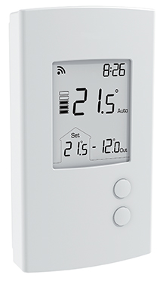

Neviweb® is a registered trademark
of Sinopé Technologies Inc.
in Canada and the United States.

Compliance with standard
CAN/CSA-C828-13



Features
Type - Wireless communication programmable, electronic, double-pole, 4-wire thermostat
for ﬂoor heating system.
Color - Standard: white.
Voltage - 120/208/240V, 50/60Hz.
Rating - 15A at 120/208/240V.
Control - 15-minute cycle.
- Resolution and precision: ± 0.5 °C (1 °F).
- Auxiliary contact offers the possibility of controlling supplemental heat sources to be added by either using a slave module (TR1310-120/240GA) for heated floors or using a low voltage relay and a low voltage transformer for an electric heater.
Temperature control mode - A mode: Ambient temperature control and possibility of limiting the temperature of the floor using an external temperature sensor.
- F mode: Floor temperature control using and external temperature sensor and
possibility of limiting the ambient temperature.
Temperature range - Floor: 5 °C (40 °F) to 30 °C (86 °F).
- Ambient: 5 °C (40 °F) to 30 °C (86 °F).
Display - Digital display of actual and setpoint temperature (°C or °F), heating level, actual mode and clock (12 or 24-hour format).
- Temperature setpoint and settings are permanently recorded.
- GFCI fault indicator.
- Backlit.
Program - Programming features are accessible only through the neviweb® Web platform.
Connection requires a GT125 interface.
Installation - 4-wire thermostat with ambient and floor sensor.
Warranty - 5-year warranty against defects.
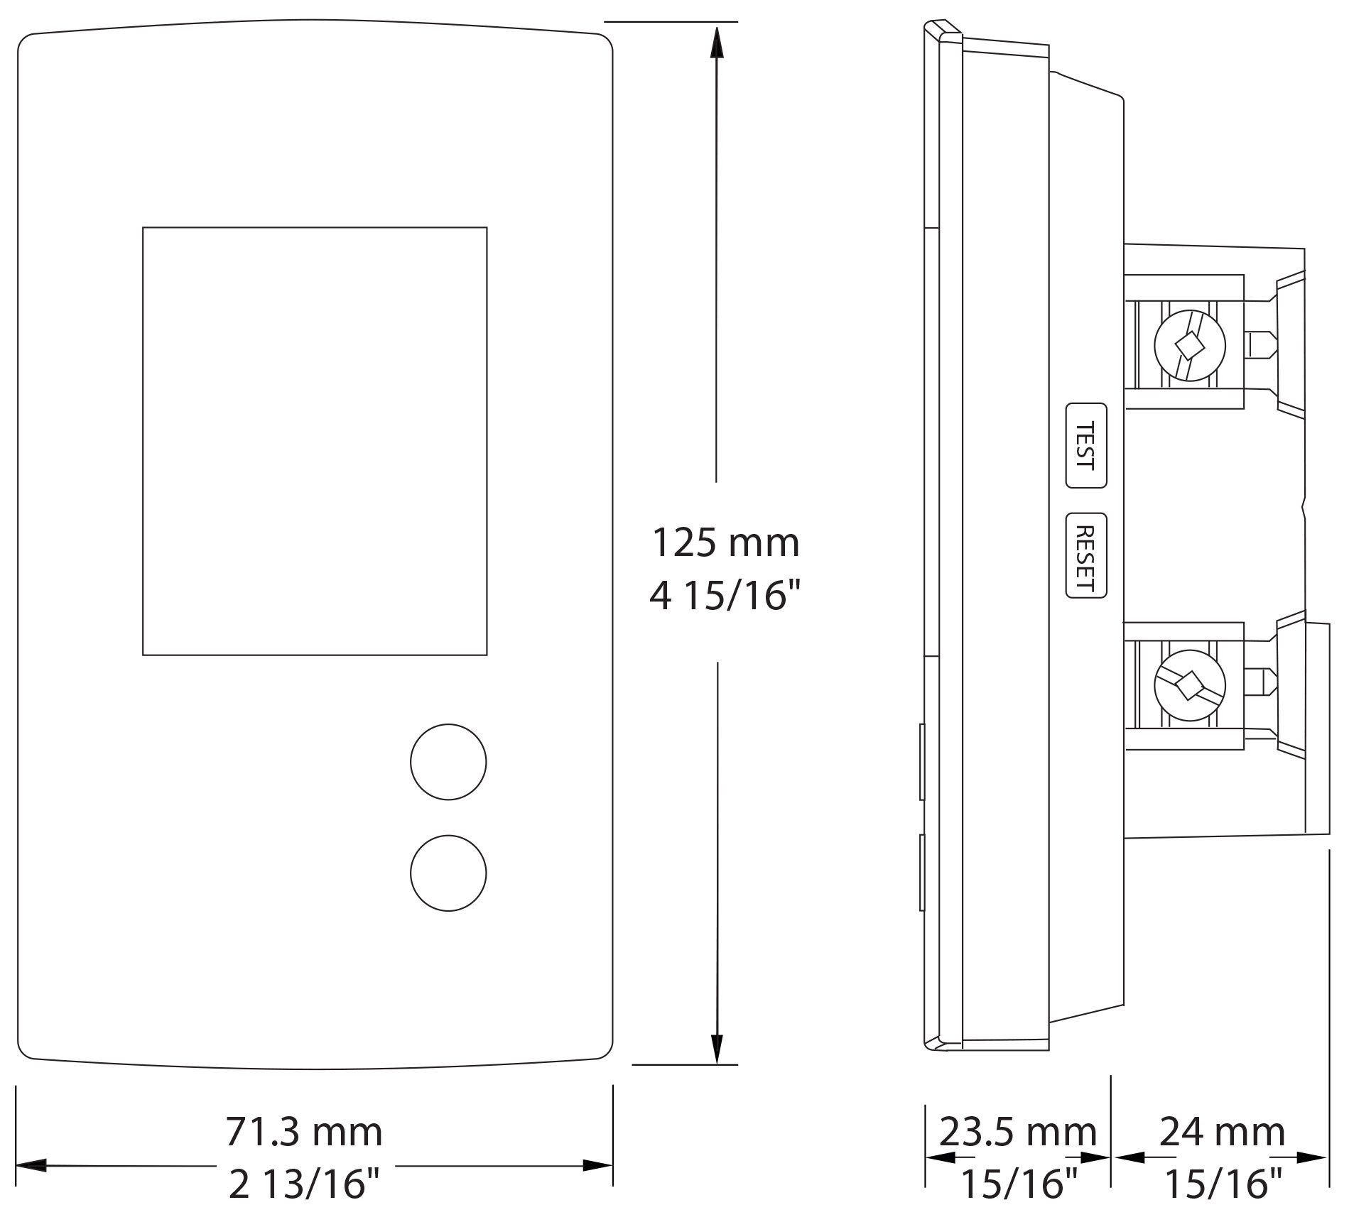
Models
Product # | Qty | Description | Amp. | Volts | Protection
OTH3600-GA-GT² |  | Wireless communication programmable electronic thermostat for floor heating system | 15 | 120/208/240 | Class A  GFCI 5 mA¹
TR1310-120/240GA |  | Slave unit for floor heating system | - | - | -
GT125 |  | Web interface that provides remote access to all your neviweb®–compatible products | - | - | -

¹ GFCI: Ground fault circuit interrupter.
² 15' (4.6 m) floor sensor included.
Standard color is white.

Specifications may change without prior notice
Project: | Approval  Information
Consultant Engineer: | Approval  Information
Electrician Contractor: | Approval  Information
Distributor: | Approval  Information
Date: | Approval  Information
Contact in Ouellet: | Approval  Information
Comments:

